**SOLUTIONS**

1. select OrderID,ProductID,UnitPrice from [Order Details]

**OUTPUT:**

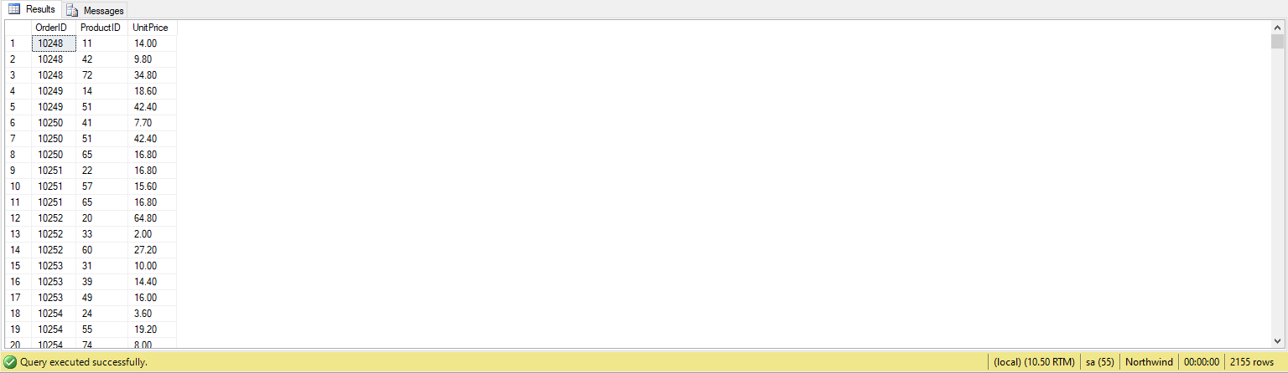

1. select Title from Employees where FirstName='Nancy'

**OUTPUT:**

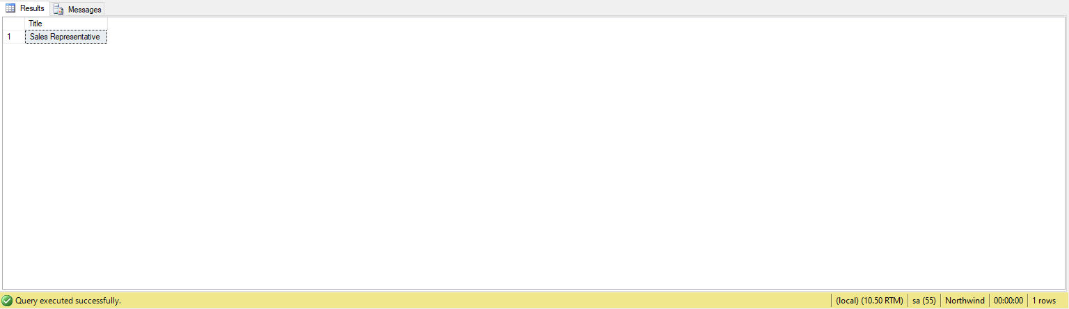

1. select * from Employees where Title = 'Sales Representative' and City='London'

**OUTPUT:**

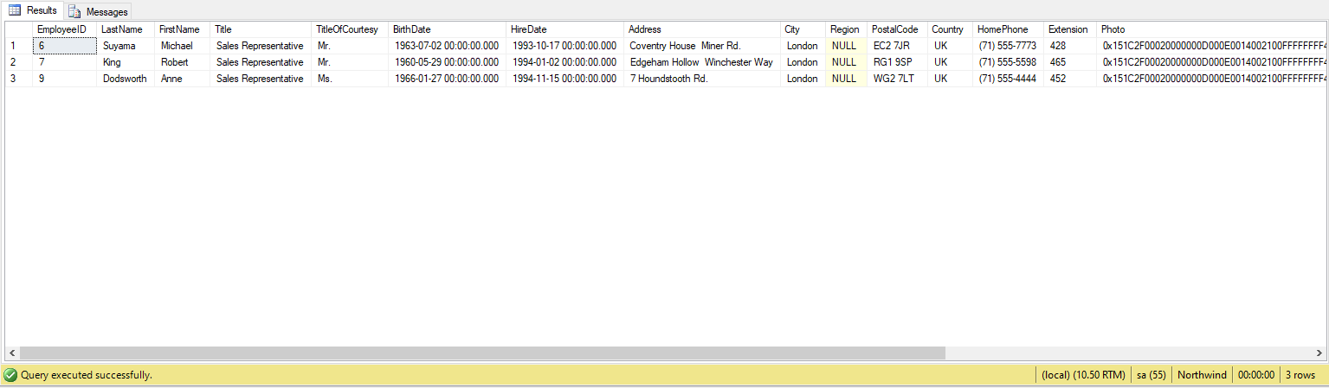

1. select ProductName from Products where UnitPrice> '90'

**OUTPUT:**

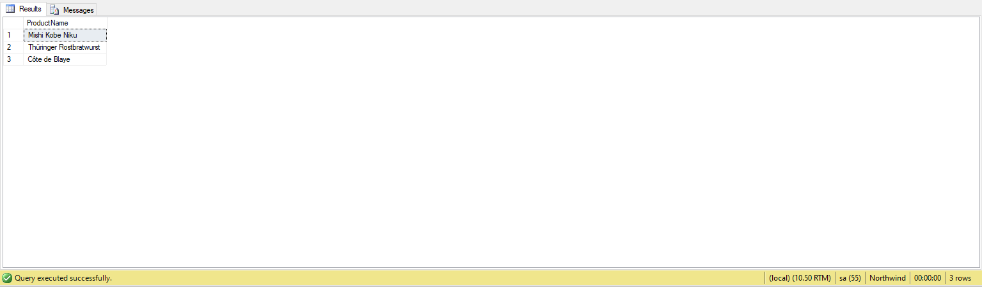

1. select ProductID,ProductName from Products where Discontinued<>1

**OUTPUT:**

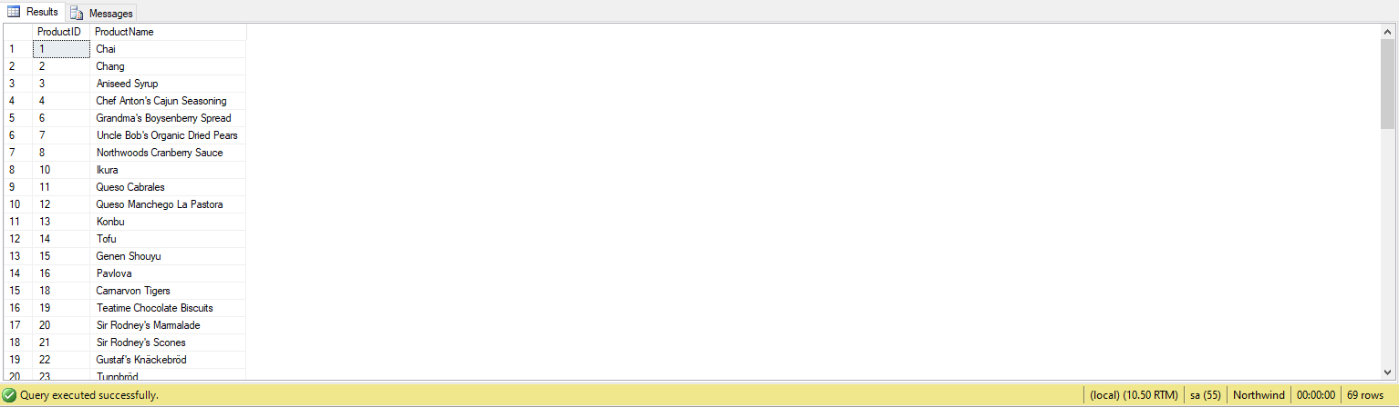

1. select * from Customers where Country='Germany' and (City='Berlin' or City='München')

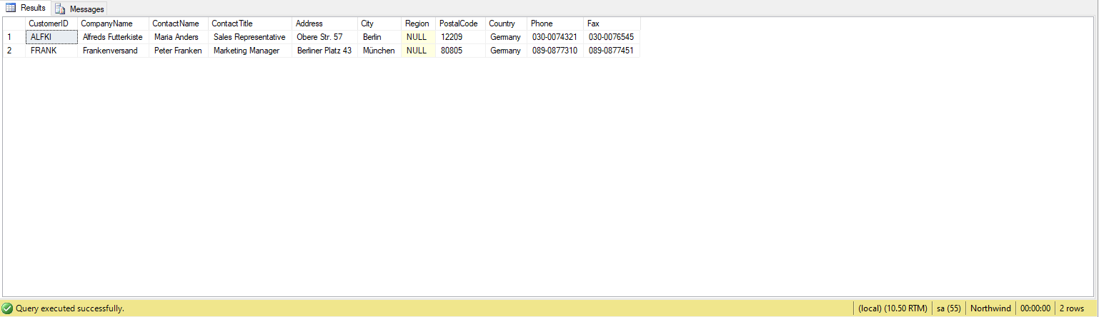

1. select * from Customers where (Country<>'Germany' and Country<>'USA')

**OUTPUT:**

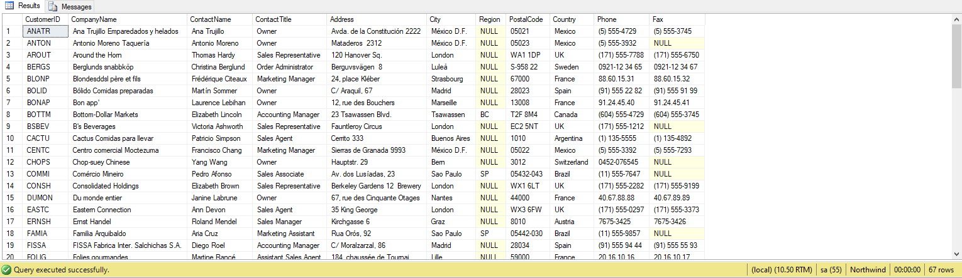

1. select * from Products where Discontinued=1 and UnitPrice>20

**OUTPUT:**

